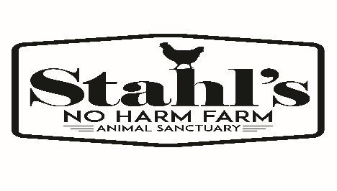
Volunteer Waiver and Agreement
I agree to become a non-compensated volunteer for Stahl’s No Harm Farm Animal Sanctuary (SNHFAS), a non- profit organization in Ohio. I shall comply with the following terms and conditions in order to best serve this organization and the rescued farm animals. I will abide by the mission, rules, regulations, policies, procedures and programs of SNHFAS while I am a volunteer. If for any reason I am unclear as to what these are, I will check with Stacie or Mark Stahl. I understand my failure to abide by the rules, regulations, policies, procedures and programs will result in my termination as a volunteer. I recognize that in handling or working around farm animals and performing other volunteer tasks there exists a risk of injury, exposure to zoonotic diseases (i.e. ringworm, giardia, rabies, lice etc.) and physical harm caused by the farm animals. On behalf of myself, my heirs, personal representatives and executors, I hereby release, discharge, indemnify and hold harmless Stahl’s No Harm Farm Animal Sanctuary, it’s agents, servants, officers, trustees, or other volunteers from any and all claims, liability, causes of action, demands, of any nature or cause, including costs and attorney fees incurred by Stahl’s No Harm Animal Sanctuary in connection with the same, based on damages or injuries which may be incurred or sustained by me in any way connected with my services for SNHFAS whether on or off SNHFAS properties, including but not limited to animal bites, being kicked, stepped on, pecked at, scratched, knocked over, accident or injury. All services will be performed at my own risk. I acknowledge and accept these conditions. To the best of my knowledge, I have accurately and truthfully filled out this volunteer application and understand and agree that SNHFAS may refuse my volunteer application at their discretion.

____________________________________________________________________________________
Printed Name
_____________________________________________________________________________________
Volunteer Signature Date
Please return this application to:
Stahl’s No Harm Farm Animal Sanctuary 1143 Lockwood Rd Coventry Township, Ohio 44203
OR via email:
Stahlsnoharm@gmail.com
4/19

